Date:26/11/2021 Roll No : 32409

Experiment No: 5

Title: Design a WEB page

Objective:

1. The design a web page using Hypertext Markup Language [HTML] and Cascading Style Sheets [CSS]

Theory :

HTML and CSS are two of the core technologies for building Web pages. HTML provides the structure of the page, CSS the (visual and aural) layout, for a variety of devices. Along with graphics and scripting, HTML and CSS are the basis of building Web pages and Web Applications.

HTML is the language for describing the structure of Web pages. Using HTML web designer

* Publish online documents with headings, text, tables, lists, photos, etc.
* Retrieve online information via hypertext links, at the click of a button.
* Design forms for conducting transactions with remote services, for use in searching for information, making reservations, ordering products, etc.
* Include spread-sheets, video clips, sound clips, and other applications directly in their documents.

With HTML, web designer describe the structure of pages using markup. The elements of the language label pieces of content such as “paragraph,” “list,” “table,” and so on.

CSS is the language for describing the presentation of Web pages, including colors, layout, and fonts. It allows one to adapt the presentation to different types of devices, such as large screens, small screens, or printers. CSS is independent of HTML and can be used with any XML-based markup language. The separation of HTML from CSS makes it easier to maintain sites, share style sheets across pages, and tailor pages to different environments. This is referred to as the separation of structure (or: content) from presentation.

**<> html**

<!DOCTYPE html>

<html lang="en">

<head>

    <meta charset="UTF-8">

    <meta http-equiv="X-UA-Compatible" content="IE=edge">

    <meta name="viewport" content="width=device-width, initial-scale=1.0">

    <link rel="stylesheet" href="style.css">

    <link rel="preconnect" href="https://fonts.googleapis.com">

    <link rel="preconnect" href="https://fonts.gstatic.com" crossorigin>

    <link href="https://fonts.googleapis.com/css2?family=Poppins:wght@100;200;300;400;600;700&display=swap"

        rel="stylesheet">

    <link rel="stylesheet" href="https://stackpath.bootstrapcdn.com/font-awesome/4.7.0/css/font-awesome.min.css">

    <title>University Website Design</title>

</head>

<body>

    <section class="header">

        <nav>

            <a href="index.html"><img src="images/logo.png" alt=""></a>

            <div class="nav-links" id="navLinks">

                <i class="fa fa-times" onclick="hideMenu()"></i>

                <ul>

                    <li><a href="">HOME</a></li>

                    <li><a href="">ABOUT</a></li>

                    <li><a href="">COURSE</a></li>

                    <li><a href="">BLOG</a></li>

                    <li><a href="">CONTACT</a></li>

                </ul>

            </div><i class="fa fa-bars" onclick="showMenu()"></i>

        </nav>

        <div class="text-box">

            <h1>World's Biggest University</h1>

            <p>Lorem ipsum dolor sit amet consectetur adipisicing elit. Hic placeat veritatis ut eum consequatur,<br>

                necessitatibus harum dicta ab incidunt doloribus.</p>

            <a href="" class="hero-btn">Visit Us To Knoe More</a>

        </div>

    </section>

*<!-- course -->*

    <section class="course">

        <h1>Course We Offer</h1>

        <p>Lorem ipsum dolor sit amet consectetur adipisicing elit. Accusamus, cumque.</p>

        <div class="row">

            <div class="course-col">

                <h3>Intermediate</h3>

                <p>Lorem, ipsum dolor sit amet consectetur adipisicing elit. Consequuntur cum voluptatum, porro

                    accusantium alias fugiat.</p>

            </div>

            <div class="course-col">

                <h3>Degree</h3>

                <p>Lorem, ipsum dolor sit amet consectetur adipisicing elit. Consequuntur cum voluptatum, porro

                    accusantium alias fugiat.</p>

            </div>

            <div class="course-col">

                <h3>Post Graduation</h3>

                <p>Lorem, ipsum dolor sit amet consectetur adipisicing elit. Consequuntur cum voluptatum, porro

                    accusantium alias fugiat.</p>

            </div>

        </div>

    </section>

*<!-- campus -->*

    <section class="campus">

        <h1>Our Global Campus</h1>

        <p>Lorem ipsum dolor sit amet consectetur adipisicing elit. Accusamus, cumque.</p>

        <div class="row">

            <div class="campus-col">

                <img src="images/london.png" alt="">

                <div class="layer">

                    <h3>LONDON</h3>

                </div>

            </div>

            <div class="campus-col">

                <img src="images/newyork.png" alt="">

                <div class="layer">

                    <h3>NEW YORK</h3>

                </div>

            </div>

            <div class="campus-col">

                <img src="images/washington.png" alt="">

                <div class="layer">

                    <h3>WASHINGTON</h3>

                </div>

            </div>

        </div>

    </section>

*<!-- facilities -->*

    <section class="facilities">

        <h1>Our Facilities</h1>

        <p>Lorem ipsum dolor sit amet consectetur adipisicing elit. Accusamus, cumque.</p>

        <div class="row">

            <div class="facilities-col">

                <img src="images/library.png" alt="">

                <h3>World Class Library</h3>

                <p>Lorem ipsum dolor sit amet consectetur adipisicing elit. Accusamus, cumque.</p>

            </div>

            <div class="facilities-col">

                <img src="images/basketball.png" alt="">

                <h3>Largest Playground</h3>

                <p>Lorem ipsum dolor sit amet consectetur adipisicing elit. Accusamus, cumque.</p>

            </div>

            <div class="facilities-col">

                <img src="images/cafeteria.png" alt="">

                <h3>Tasty & Healthy Food</h3>

                <p>Lorem ipsum dolor sit amet consectetur adipisicing elit. Accusamus, cumque.</p>

            </div>

        </div>

    </section>

*<!-- testimonials -->*

    <section class="testimonials">

        <h1>What Our Student Says</h1>

        <p>Lorem ipsum dolor sit amet, consectetur adipiscing elit.</p>

        <div class="row">

            <div class="testimonial-col">

                <img src="images/user1.jpg">

                <div>

                    <p>Lorem ipsum dolor sit amet, consectetur adipiscing elit. Pellentesque aliquet turpis nulla,

                        eleifend faucibus est sollicitudin ut. Maecenas ut venenatis ex, et dapibus purus.</p>

                    <h3>Christine Berley</h3>

                    <i class="fa fa-star"></i>

                    <i class="fa fa-star"></i>

                    <i class="fa fa-star"></i>

                    <i class="fa fa-star"></i>

                    <i class="fa fa-star-o"></i>

                </div>

            </div>

            <div class="testimonial-col">

                <img src="images/user2.jpg">

                <div>

                    <p>Lorem ipsum dolor sit amet, consectetur adipiscing elit. Pellentesque aliquet turpis nulla,

                        eleifend faucibus est sollicitudin ut. Maecenas ut venenatis ex, et dapibus purus.</p>

                    <h3>David Barkey</h3>

                    <i class="fa fa-star"></i>

                    <i class="fa fa-star"></i>

                    <i class="fa fa-star"></i>

                    <i class="fa fa-star"></i>

                    <i class="fa fa-star-half--o"></i>

                </div>

            </div>

        </div>

*<!-- call to action -->*

        <section class="cta">

            <h1>Enroll For Our Various Online Courses<br>Anywhere From The World</h1>

            <a href="" class="hero-btn">CONTACT US</a>

        </section>

*<!-- footer -->*

        <section class="footer">

            <h4>About Us</h4>

            <p>Lorem ipsum dolor sit amet, consectetur adipiscing elit. Pellentesque aliquet turpis nulla, <br> eleifend

                faucibus est sollicitudin ut. Maecenas ut venenatis ex, et dapibus purus.</p>

            <div class="icons">

                <i_ class="fa fa-facebook"></i>

                <i class="fa fa-twitter"></i>

                <i class="fa fa-instagram"></i>

                <i class="fa fa-linkedin"></i>

            </div>

            <p>Made with <i class="fa fa-heart-o"></i> by Anisha R B (32409)</p>

        </section>

*<!-- javascript for toggle menu -->*

        <script>

            var navLinks = document.getElementById("navLinks");

            function showMenu() {

                navLinks.style.right = "0";

            }

            function hideMenu() {

                navLinks.style.right = "-200px";

            }

        </script>

</body>

</html>

**#css**

*{

    margin: 0;

    padding: 0;

    font-family: 'Poppins', sans-serif;

}

.header{

    min-height: 100vh;

    width: 100%;

    background-image: linear-gradient(rgba(4,9,30,0.7),rgba(4,9,30,0.7)), url(images/banner.png);

    background-position: center;

    background-size: cover;

    position: relative;

}

nav{

    display: flex;

    padding: 2% 6%;

    justify-content: space-between;

    align-items: center;

}

nav img {

    width: 150px;

}

.nav-links{

    flex: 1;

    text-align: right;

}

.nav-links ul li{

    list-style: none;

    display: inline-block;

    padding: 8px 12px;

    position: relative;

}

.nav-links ul li a{

    color: white;

    text-decoration: none;

    font-size: 13px;

}

.nav-links ul li::after{

    content: '';

    width: 0%;

    height: 2px;

    background: #f44336;

    display: block;

    margin: auto;

    transition: 0.5s;

}

.nav-links ul li:hover::after{

    width: 100%;

}

.text-box{

    width: 90%;

    color: #fff;

    position: absolute;

    top: 50%;

    left: 50%;

    transform: translate(-50%,-50%);

    text-align: center;

}

.text-box h1{

    font-size: 62px;

}

.text-box p{

    margin: 10px 0 40px;

    font-size: 14px;

    color: #fff;

}

.hero-btn{

    display: inline-block;

    text-decoration: none;

    color: #fff;

    border: 1px solid #fff;

    padding: 12px 34px;

    font-size: 13px;

    background: transparent;

    position: relative;

    cursor: pointer;

}

.hero-btn:hover{

    border: 1px solid #f44336;

    background: #f44336;

    transition: 1s;

}

nav .fa{

    display: none;

}

@media(max-width: 700px){

    .text-box h1{

        font-size: 20px;

    }

    .nav-links ul li{

        display: block;

    }

    .nav-links{

        position: absolute;

        background: #f44336;

        height: 100vh;

        width: 200px;

        top: 0;

        right: -200px;

        text-align: left;

        z-index: 2;

        transition: 1s;

    }

    nav .fa{

        display: block;

        color: #fff;

        margin: 10px;

        font-size: 22px;

        cursor: pointer;

    }

    .nav-links ul{

        padding: 30px;

    }

}

*/* course */*

.course{

    width: 80%;

    margin: auto;

    text-align: center;

    padding-top: 100%;

}

h1{

    font-size: 36px;

    font-weight: 600;

}

p{

    color: #777;

    font-size: 14px;

    font-weight: 300;

    line-height: 22px;

    padding: 10px;

}

.row{

    margin-top: 5%;

    display: flex;

    justify-content: space-between;

}

.course-col{

    flex-basis: 31%;

    background: #fff3f3;

    border-radius:10px ;

    margin-bottom: 5%;

    padding: 20px 12px;

    box-sizing: border-box;

    transition: 0.5s;

}

h3{

    text-align: center;

    font-weight: 600;

    margin: 10px 0;

}

.course-col:hover{

    box-shadow: 0 0 20px 0px rgba(0,0,0,0.2);

}

@media(max-width: 700px){

    .row{

        flex-direction: column;

    }

}

*/* campus */*

.campus {

    width: 80%;

    margin: auto;

    text-align: center;

    padding-top: 50px;

}

.campus-col{

    flex-basis: 32%;

    border-radius: 10px;

    margin-bottom: 30px;

    position: relative;

    overflow: hidden;

}

.campus-col img{

    width: 100%;

    display: block;

}

.layer{

    background: transparent;

    height: 100%;

    width: 100%;

    position: absolute;

    top: 0;

    left: 0;

    transition: 0.5s;

}

.layer:hover{

    background: rgba(226,0,0,0.7);

}

.layer h3{

    width: 100%;

    font-weight: 500;

    color: #fff;

    font-size: 26px;

    bottom: 0;

    left: 50%;

    transform: translateX(-50%);

    position: absolute;

    opacity: 0;

    transition: 0.5s;

}

.layer:hover h3{

    bottom: 49%;

    opacity: 1;

}

*/* Facilities */*

.facilities{

    width: 80%;

    margin: auto;

    text-align: center;

    padding-top: 100px;

}

.facilities-col{

    flex-basis: 31%;

    border-radius: 10px;

    margin-bottom: 5%;

    text-align: left;

}

.facilities-col img{

    width: 100%;

    border-radius: 10px;

}

facilities-col p{

    padding: 0;

}

.facilities-col h3{

    margin-top: 16px;

    margin-bottom: 15px;

    text-align: left;

}

*/* testimonials ------*/*

.testimonials {

    width: 80%;

    margin: auto;

    padding-top: 100px;

    text-align: center;

}

.testimonial-col{

    flex-basis: 44%;

    border-radius: 10px;

    margin-bottom: 5%;

    text-align: left;

    background: #fff3f3;

    padding: 25px;

    cursor: pointer;

    display: flex;

}

.testimonial-col img{

    height: 40px;

    margin-left: 5px;

    margin-right: 30px;

    border-radius: 50%;

}

.testimonial-col p{

    padding: 0;

}

.testimonial-col h3{

    margin-top: 15px;

    text-align: left;

}

.testimonial-col .fa{

    color: #f44336;

}

@media(max-width: 700px){

    .testimonial-col img{

        margin-left: 0px;

        margin-right: 15px;

}

*/* call to action */*

.cta{

    margin: 100px auto;

    width: 80%;

    background-image: linear-gradient(rgba(4,9,30,0.7),rgba(4,9,30,0.7)), url(images/banner2.jpg);

    background-position: center;

    background-size: cover;

    border-radius: 10px;

    text-align: center;

    padding: 100px 0;

}

.cta h1{

    color: #fff;

    margin-bottom: 40px;

    padding: 0; }

}

@media(max-width: 700px){

    .cta h1{

        font-size: 24px;

    }

}

*/* footer  */*

.footer {

    width: 100%;

    text-align: center;

    padding: 30px 0;

}

.footer h4{

    margin-bottom: 25px;

    margin-top: 20px;

    font-weight: 600;

}

.footer .fa{

    color: #f44336;

    margin: 0 13px;

    cursor: pointer;

    padding: 18px 0;

}

.fa fa-heart-o{

    color: #f44336;

}

Design: **output**



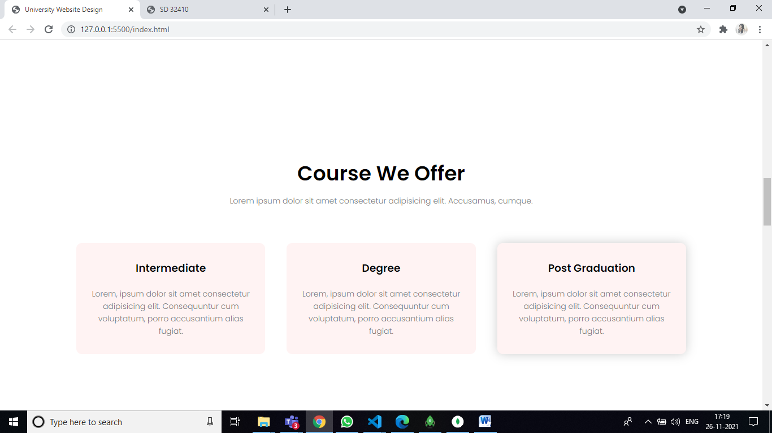

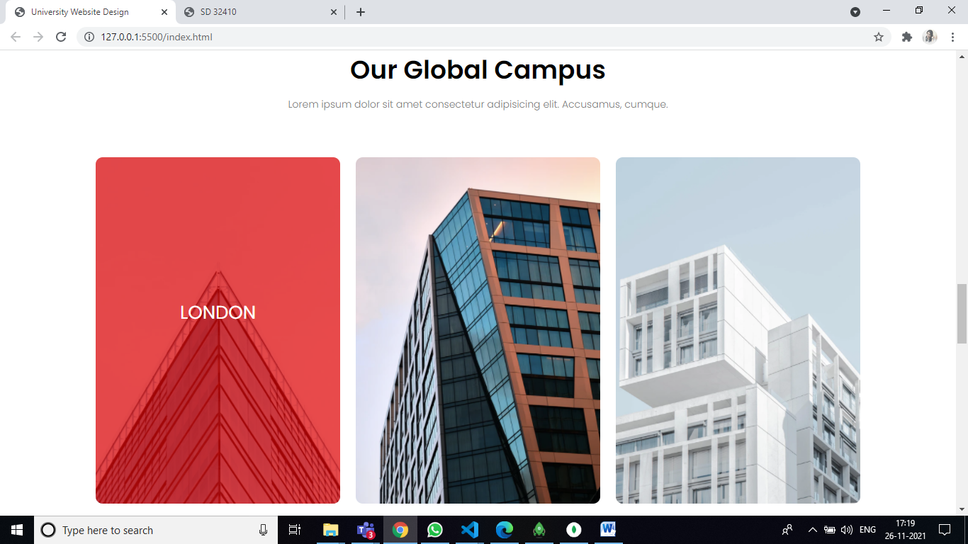

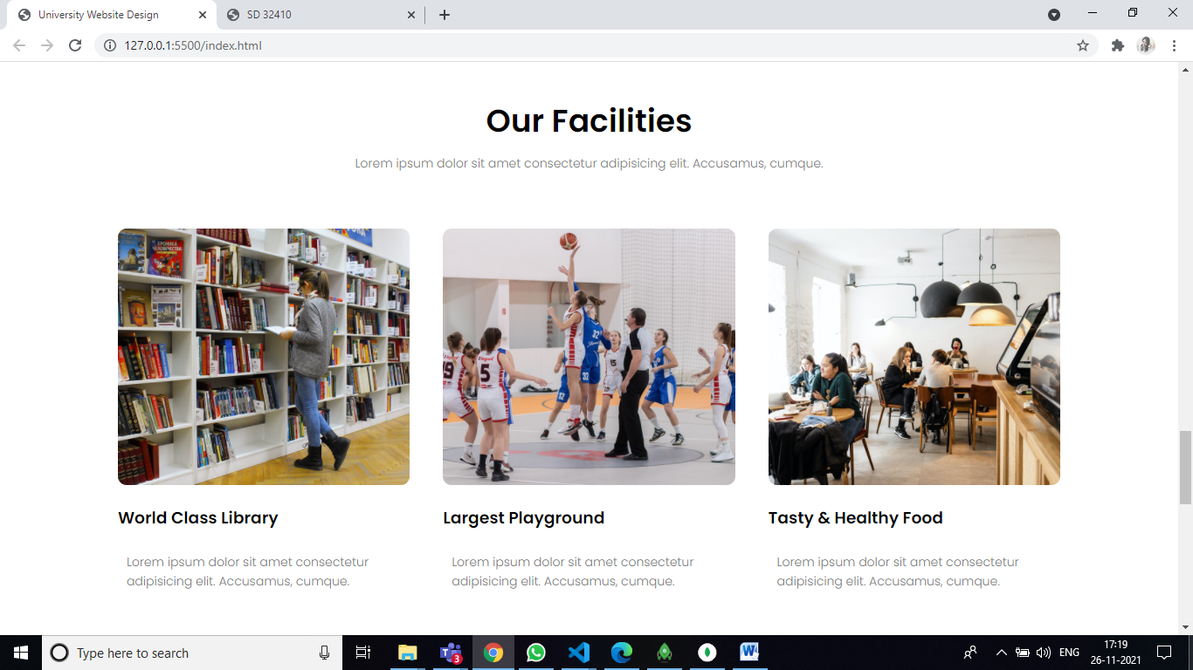

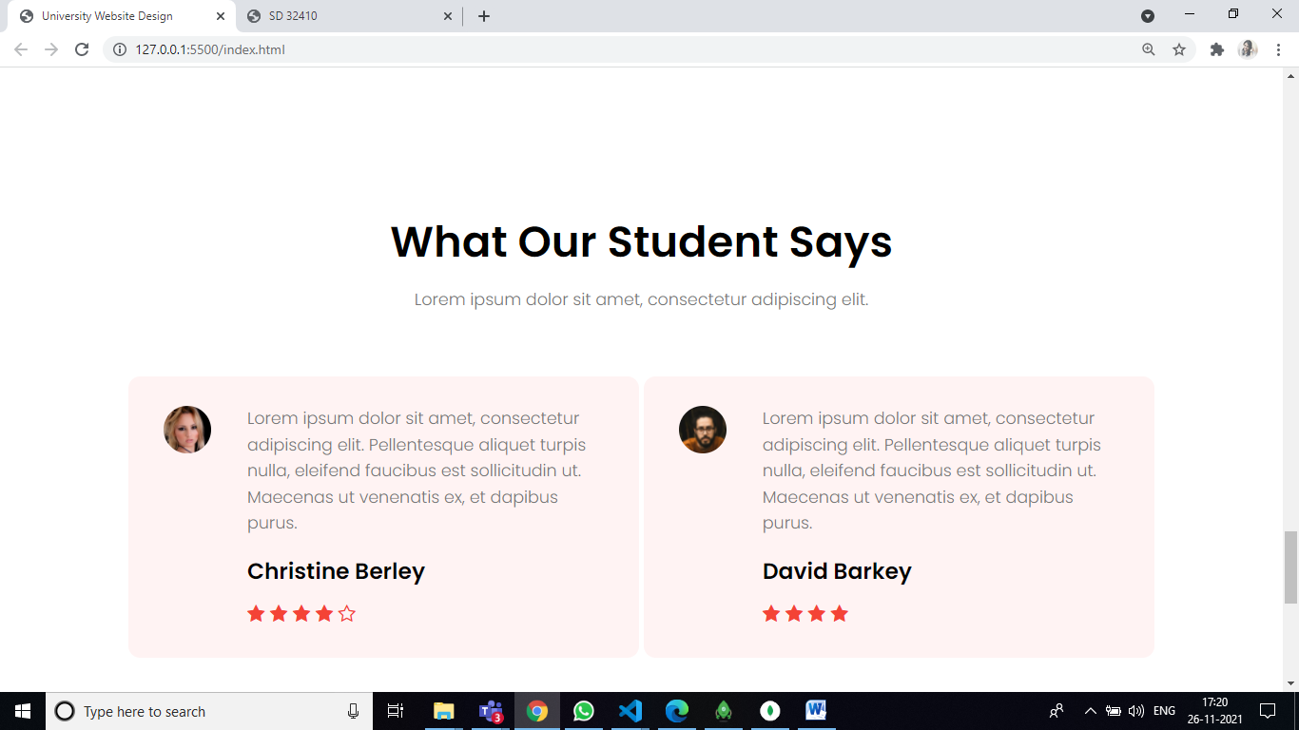

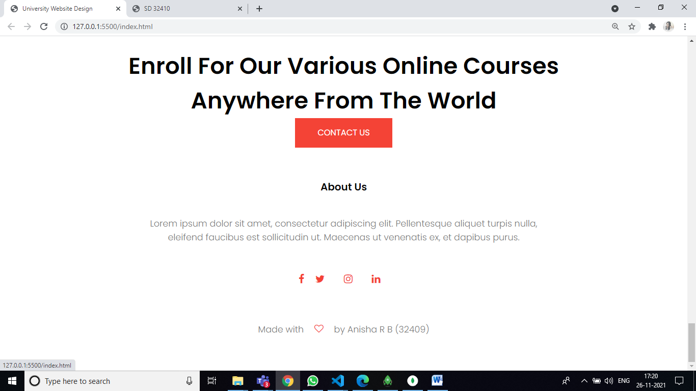

Conclusion :